8 BIT SUBTRACTION

# EXP NO: 02

# AIM:

# TO write an assembly language program to implement 8-bit Subtraction using 8085 processor.

# ALGORITHM:

1. Start the program by loading the first data into the accumulator.

2. Move the data to a register.

3. Get the second data and load it into the accumulator.

4. subtracting the two register contents.

5. check for subtraction

6. store the value of difference and borrow in the memory location

7. Halt.

# PROGRAM:

LDA 4500

MOV B,A

LDA 4501

SUB B

STA 4502

RST 1

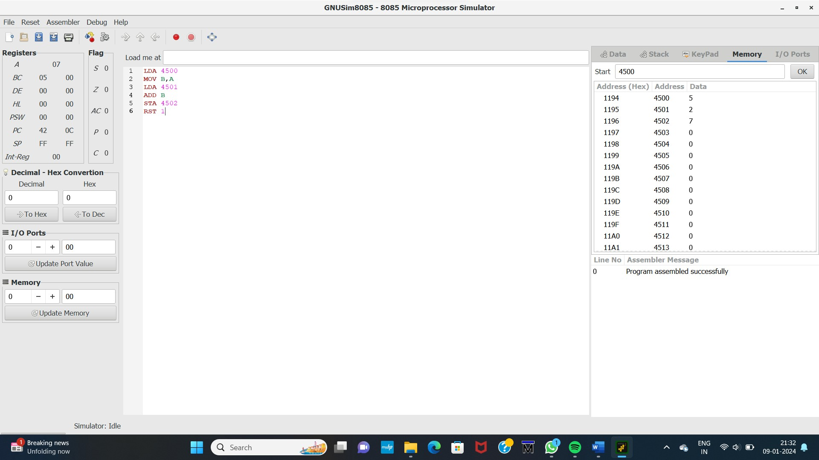

# INPUT:

# 

# Output:

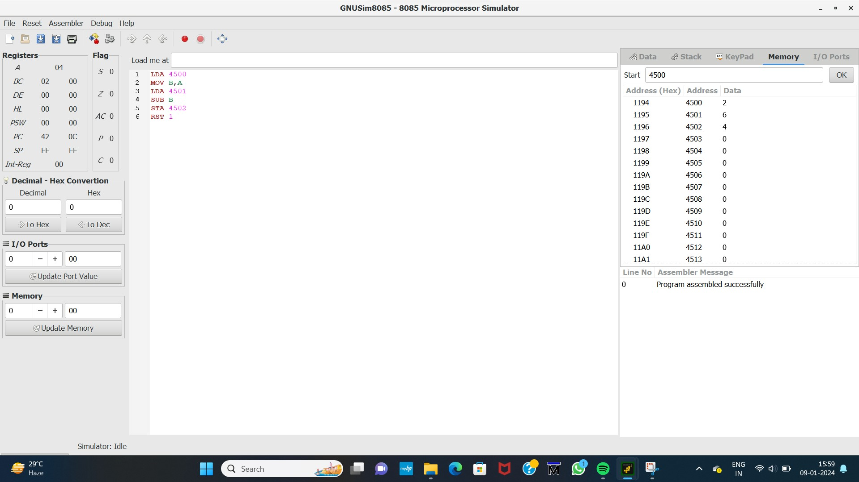

# Result:

Thus the program was executed successfully using 8085 processor stimulator